Deer Lake Conservancy Annual Report 2021
ENJOY THE OUTDOORS WITH CONSERVANCY TRAILS
The Deer Lake Conservancy developed several new trails over the past year, and we now have almost six miles of trails through our conservation areas. Look for the Deer Lake Conservancy “Conservation Trail” signs to access all of our trails. Trail maps are found on our website Trail Maps - Deer Lake Conservancy (dlcwi.org), and a new trail brochure will be available soon!
Work on our trails and property is supported by generous contributions from our members, the Trillium Family Foundation, the Longview Foundation, and other private foundations.
Watershed 1 Pond Preserve Trail
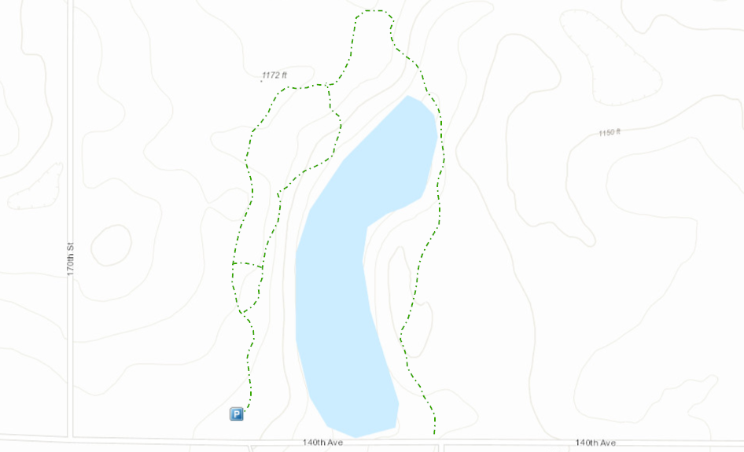
With the help of volunteers from the Conservancy’s trail crew, we developed a loop trail around the North Pond. You can find the trail on the north side of 140th Avenue across from 167th Street, and parking is just to the west on the other side of the pond. This trail winds through a pine forest, into a remnant prairie, across a spring fed stream (which runs even in the winter), and around a marsh, with occasional views of the pond. A spur trail on the west side of the pond descends a slope to the edge of the pond, crosses a stream, and climbs the hill back to the main trail loop.
As you descend to the pond, you may see trumpeter swans. In their sixth year of nesting, the swans are raising six signets, up from two in previous years! Trumpeter swans are the largest waterfowl in North America. They mate for life, and will return to a nesting site year after year. Trumpeter swans have made a dramatic comeback after being nearly extinct in the 1930s when there were fewer than 70 individuals known to exist (Cornell Lab of Ornithology). Please keep your distance from the swans. They are sensitive to disturbance and may abandon their nest if the young are disturbed.
Trumpeter Swans and Signets
The pond on this preserve is the second largest source of spring water to Deer Lake, after the Conservancy-owned Rock Creek Conservation Area.
Johnson Preserve
Elizabeth’s Pond Trail
We also built a new trail around the north side of Elizabeth’s Pond. The trailhead (a grassy parking area) is located on the west side of Anderson Lane. The trail crosses a ravine that fills the pond with runoff and wetland drainage from north of 140th Avenue, west of 180th Street. The trail was constructed in the fall of 2020 after we raised the culvert, and therefore water levels in the pond, to add more holding capacity. By adding holding capacity to the pond, we are able to reduce downstream erosion in a stream that flows to Dry Creek then to Deer Lake. The trail traverses prairie that was planted along the pond’s north-slope as part of the project. In the early spring you can see woodland wildflowers and remnant plantings of lovely snow lilies and heirloom daffodils along the trail in the woods.
Jenny’s Pond Trail
A former trail was also restored along the north edge of Jenny’s pond. You can find this trail by travelling east across Anderson Lane from the Elizabeth Pond trail. Or, access the trail on the south side of 140th Avenue just to the west of the Dry Creek parking area.
Elizabeth’s Pond
Jenny’s Pond
A HUGE THANK YOU TO TRAIL CREW VOLUNTEERS: Jay Becker, Mary Becker, Mark Becker, Pat Corcoran, Sandy Corcoran, Don Knutson, Jim Miller, Adam Ross, Ken Roberts, Patti Roberts, Mike Theis, Mary Theis, and Denise Wright! We also thank others who pick up sticks as they walk along the trail!
Interested in volunteering to develop and maintain Conservancy trails? Join the Deer Lake Conservancy Trail Crew! Contact Jim Miller at 715-483-3338 or dlcdirector@dlcwi.org
Trail Walk and Learn Events
We learned more about the birds of the Johnson Preserve and plants of the Flagstad Farm Preserve at Walk and Learn events this summer. Brian Collins, who conducts bird surveys in the wilds of Wisconsin each summer, and Barb Delaney, retired botanist, shared their love and knowledge of nature at these events. Contact us with requests for future events dlcdirector@dlcwi.org .
SUPPORTING HABITAT FOR RARE SPECIES
Deer Lake Conservancy preserves are home to a number of rare species including Red Shouldered Hawk (Wisconsin Threatened Species) and Blanding’s Turtle (Wisconsin Special Concern Species) on the Johnson Preserve. The Flagstad Farm Preserve prairie provides habitat for the Henslow’s Sparrow (Wisconsin Threatened Species). Trumpeter Swans, once nearly extinct and listed as endangered, now thrive in ponds across northwest Wisconsin including on our Watershed 1 Pond Preserve. Our prairies contain native prairie plants that had been virtually extinct in Wisconsin for more than 100 years, since the rise of mechanized agriculture
CONTROLLING INVASIVE BUCKTHORN
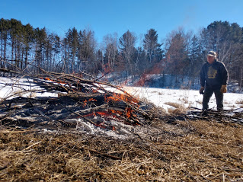
The Deer Lake Conservancy began invasive species control efforts in 2007, and we continue the battle today. Our focus is removal of buckthorn, a tenacious invasive shrub. The Wisconsin Department of Natural Resources, Wisconsin Forest Landowner Grant program, supported our efforts for many years with assistance from Polk County DNR Forester Paul Heimstead. The Conservancy recently applied for a 2-year grant for buckthorn control in the Watershed 1 Pond Preserve and the Johnson Preserve. Buckthorn control is completed by Dan Cain of Habitat Creations LLC in the fall. Dead buckthorn is cut and burned by Conservancy volunteers in the winter.
Volunteer, Jay Becker, burns buckthorn at the Watershed 1 Pond Preserve
WATER QUALITY PROJECTS
With the WDNR-approved 2020 Deer Lake Management Plan in hand, we successfully applied for a $200,000 Surface Water Grant from the Wisconsin Department of Natural Resources. The grant period runs from March 15, 2021 through December 31, 2023. The grant will allow continuation of our popular Direct Drainage Program which provides grants to homeowners to install rain gardens, rock infiltration, native plantings, and diversions to reduce runoff that enters Deer Lake from their property.
The grant will also fund projects on Conservancy properties. Many of us around the lake have seen impacts from more frequent, high intensity storms. These storms increase erosion along the intermittent stream channels that carry resulting sediment to the lake. Some of the grant funds will be used this year to stabilize streambanks draining the watersheds on the north side of Deer Lake, repair damage caused by intense storms, and stabilize our trail system to withstand heavy rains.
Project Operation and Maintenance
With over 25 years of work installing projects to reduce runoff of phosphorus to Deer Lake, we have a legacy of good work to maintain. There are dozens of conservation projects in large watershed drainage areas, and projects installed on more than 55 private parcels around Deer Lake. While landowners are generally responsible to maintain projects on their own property, the Conservancy must ensure that larger projects are inspected and maintained so their water quality benefits are lasting.
Several volunteers learned about what to look for and how to record the results of inspections in training provided this spring by staff from the Polk County Land and Water Resources Department. Polk County provided engineering support for several of our first large projects. If you would like to lend a hand by inspecting projects in one of our watershed areas and/or join a team to help maintain projects, contact our Executive Director, Cheryl Clemens at 715-268-9992 or dlcdirector@dlcwi.org. We’d love to have you as part of the team!
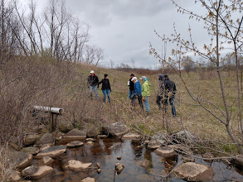
Shoreline Survey
Another component of the new DNR grant is a survey of the Deer Lake shoreline. The area next to the water provides critical habitat for creatures who live in and near the lake. The cover on this land greatly influences the amount nutrients and sediment carried to the lake from our properties, and therefore, lake water quality.
Technicians will be out surveying the shoreline the last week of July. The survey involves a boat cruising near the shoreline with people taking notes and photos. The results will help us target outreach regarding our use and development of near shore areas and to understand changes since a similar survey was completed in 2003.
Deer Lake Conservancy 2021 Annual Meeting
Flagstad Farm Preserve
Saturday, August 14
Refreshments and Welcome: 8:30 a.m.
Business Meeting: 9:00 a.m.

2021 Deer Lake Conservancy Officers and Directors
Heartfelt thanks go out to Deer Lake Conservancy members who support us. Our mission is to preserve Deer Lake and the surrounding land that contributes to its natural, scenic and recreational value.
To join or make an additional contribution, go to: https://www.dlcwi.org/contributing or mail a check to:
Deer Lake Conservancy
P.O. Box 1139
St. Croix Falls, WI 54024
For more information, visit our website: https://www.dlcwi.org

